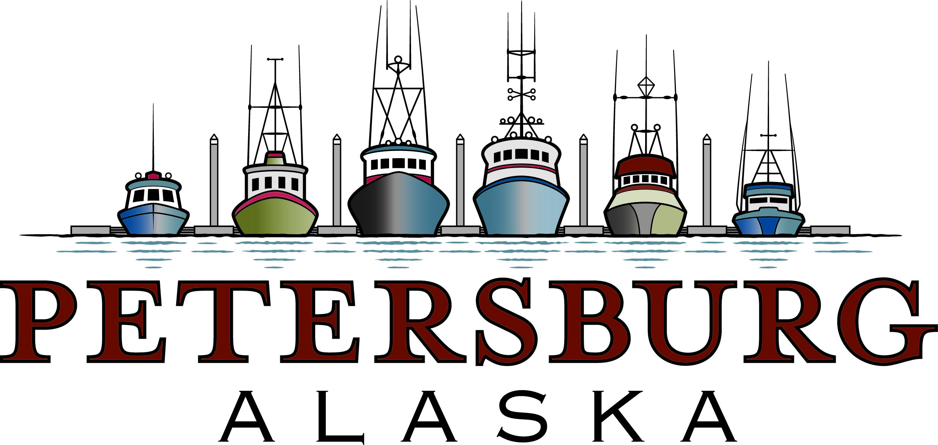

November 16, 2020

The Honorable Lisa Murkowski
Chairman
Senate Committee on Energy & Natural Resources
304 Dirksen Senate Office Building
Washington, DC 20510

Dear Chairman Murkowski:

The Petersburg Borough Assembly wishes to offer the following comments on S. 4889 – The Alaska Native Claims Settlement Act Fulfillment Act of 2020. I would respectfully request that our comments be included as part of the hearing record on the bill to be held by your Subcommittee on Public Lands, Forests & Mining on November 18.

These comments pertain to the sections of the bill that include the Unrecognized Southeast Alaska Native Communities Recognition and Compensation Act. As you know the bill sets aside 23,040 acres of Federal land within our Borough’s boundaries for withdrawal to a prospective Urban Corporation made up of native landless village residents from our area. Many of our resident Native Alaskan population would benefit from these withdrawals. We recognize your intent to correct an oversight that occurred when ANSCA passed and did not authorize land withdrawals to the native communities in the five Southeast Alaska communities. We wish to acknowledge the efforts by your staff to provide us with earlier drafts of the bill along with withdrawal maps and to continuing dialog with us to address any concerns.

Introduction of the bill, followed quickly by a hearing and the possibility of prompt consideration and enactment in the waning days of this Congress does concern us, given that we have not had adequate time to vet within Petersburg the proposed withdrawal areas along with the bill’s process for conveyance to ensure community concerns over recreational, road, cabin, trail, and rights-of-way access to the public are adequately protected. For example, some of the proposed withdrawal areas are heavily used by our residents for hunting, fishing and subsistence purposes. That includes popular hunting areas and cabin use in Portage Bay. That area is adjacent to the Kake Access Road that, once built, will facilitate the movement of people and vehicles from Kake which will connect onto roads that will be in the withdrawal areas. Part of the new road will also traverse one of the areas.

Also, many of the trails and roads on Forest Service land the community now has access to are through informal agreement. The Borough has no explicit agreements with the Forest Service for assured public access that would necessarily convey. We understand under the terms of the legislation that the Forest Service and Bureau of
Land Management would seek to protect public easements as part of the conveyances of the withdrawal areas. Without formal agreements in place we are uncertain that the Federal agencies would be able to protect public, commercial and non-commercial access to these areas that our residents currently enjoy. The agencies could also choose not to protect public access, and we would have little recourse. The bill does include access for non-commercial recreational public use, subject to “reasonable restrictions.” We are concerned that the Urban Corporation might selectively interpret that phrasing to restrict access in ways that the bill does not intend. Lastly, we would like more dollar amount specificity on how the loss of Federal acreage will impact our annual Secure Rural Schools and Payment-In-Lieu-of-Taxes payments, assuming due to the formulas in those calculations that there is an impact.

For these reasons, we would respectively request that you refrain from trying to enact the bill this year. We would like more time to discuss its provisions and withdrawal areas within our community, gather the views of fishermen, hunters, recreation users, landless village residents and potential Urban Corporation members, our local Forest Service District, and others to understand the ramifications of the bill and how, on a practical level, it would be implemented in Petersburg. We pledge to work with you and your staff on developing appropriate safeguards to address these concerns that can hopefully be incorporated in a new bill to be considered in the next Congress.

Thank you for consideration of these views and for your long-time support of our community.

Sincerely,

Mark Jensen
Mayor

Cc: The Honorable Dan Sullivan
The Honorable Don Young

